Name: Student ID:

Lab Section: Date:

# **Prelab**

1. What is the operating voltage of the SN74HCT257N Chip?
2. The SN74HCT257N chip consists of four 2-to-1 multiplexers that share a common select line. The spec sheet uses 1-based indexing for the input and output pins. On the diagram below, relabel these pins to use 0-based indexing. You will need this relabeling when you start wiring the circuit.

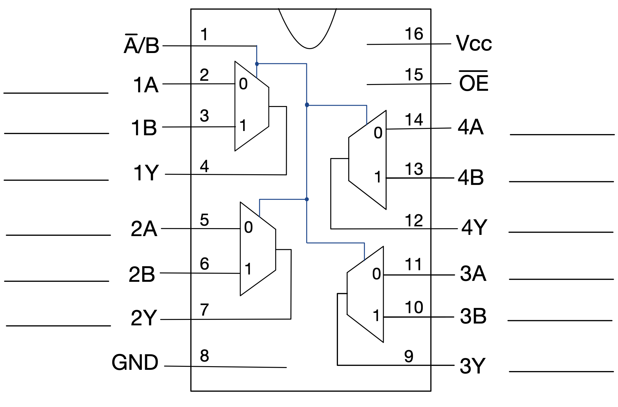

1. On the diagram below, connect inputs P and Q to any MUX of the SN74HCT257N chip. Connect the output of the MUX to the box labeled “Out”. Use Vcc and GND to power the chip, to enable the output, and to select line P as the output.

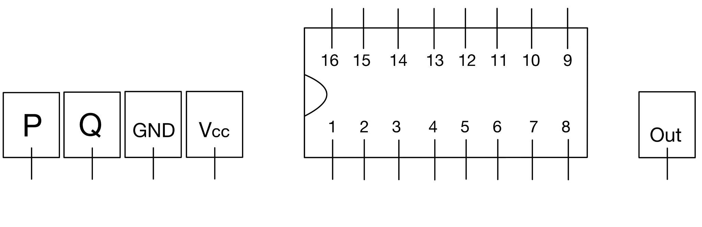

# 

# 

# 

# **Lab**

**4.1**

Verify that you placed your chips, connectors, power and ground wires correctly. Show your progress on the breadboard implementation to the TA before you proceed. (25 pts)

TA Initials:

**4.3**

Verify that you connected the inputs to the SN74HCT257N chips correctly. Show your progress on the breadboard implementation to the TA before you proceed. (25 pts)

TA Initials:

**4.5**

Verify that you connected the outputs from the SN74HCT257N chips to the output connector correctly. Also, verify that you connected the select wire to both chips and the LED. Make sure that the cathode of the LED is connected to ground. Show your completed breadboard implementation to the TA before you proceed. (25 pts)

TA Initials:

**5.2**

Verify that your circuit is correctly attached to the tester. Then, create and perform three tests or test sequences. The first test should check if all bits in the input bus A correctly propagate to the output. The second test should make sure that all bits of input bus B propagate to the output correctly. The third test should test a common issue when building a bus mux, swapped neighboring bits. Create a test sequence to ensure that bit Ak is not accidentally swapped with either Ak-1 or Ak+1 all possible values of k. Do the same for the bits of the B bus. (25 pts)

|  | Input bus A | Input bus B | Select Line | Output bus Y |
| --- | --- | --- | --- | --- |
| Example Test | 11001110 | 00000000 | 0 | 11001110 |
| Test 1 |  |  |  |  |
|  |  |  |  |  |
|  |  |  |  |  |
| Test 2 |  |  |  |  |
|  |  |  |  |  |
|  |  |  |  |  |
| Test 3 |  |  |  |  |
|  |  |  |  |  |
|  |  |  |  |  |
|  |  |  |  |  |

Verify that your tests accurately demonstrate the expected behavior for a bus multiplexer. Show your tests to the TA using your circuit and the tester.

TA Initials: